**4.a Course Name: Javascript Module Name: Types of Functions, Declaring and Invoking Function, Arrow Function, Function Parameters, Nested Function, Built-in Functions, Variable Scope in Functions Write a JavaScript code to book movie tickets online and calculate the total price based on the 3 conditions: (a) If seats to be booked are not more than 2, the cost per ticket remains Rs. 150. (b) If seats are 6 or more, booking is not allowed. (c) If seats to be booked are more than 2 but less than 6, based on the number of seats booked, do the following - Calculate total cost by applying a discount of 3, 5, 7, 9, 11 percent, and so on for customers till 5 respectively. Try the code with different values for the number of seats. Write the following custom functions to implement given requirements: i. calculateCost(seats): Calculate and display the total cost to be paid by the customer for the tickets they have bought. ii. calculateDiscount(seats): Calculate discount on the tickets bought by the customer. Implement using arrow functions.**

**Program:**

<!DOCTYPE html>

<html>

<head>

<title>Booking Summary Using Functions</title>

</head>

 <body>

<center>

<div>

<h2>Booking Summary</h2>

</div>

<div>

<script>

var a;

var b;

function nooftickets()

{

a=prompt("enter no of tickets");

document.write("no of tickets booked are:"+a+"<br>");

}

function discount()

{

if(a<=2)

{

document.write("No Discount<br>");

}

else if(a>=6)

{

document.write("invalid no of tickets booked <br> Book tickects in b/w 1 to 6");

}

else

{

if(a==3)

{

b=(150*(3/100))+(150*(5/100))+(150*(7/100));

}

else if(a==4)

{

b=(150*(3/100))+(150*(5/100))+(150*(7/100))+(150*(9/100));

}

else if(a==5)

{

b=(150*(3/100))+(150*(5/100))+(150*(7/100))+(150*(9/100))+(150*(11/100));

}

if(a<6)

document.write("Discount is: Rs."+b+"<br>");

}

}

function total()

{

document.write("total price is: Rs."+(a*150)+"<br>");

}

function Offer()

{

document.write("offer price is:Rs."+((a*150)-b)+"<br>");

}

nooftickets();

discount();

if(a<6)

{

total();

Offer();

}

</script></div></center></body></html>

**Output:**

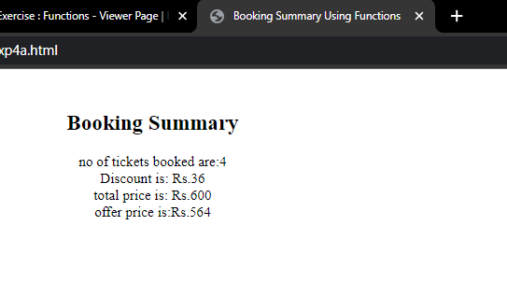

**4.b Course Name: Javascript Module Name: Working With Classes, Creating and Inheriting Classes Create an Employee class extending from a base class Person. Hints: (i) Create a class Person with name and age as attributes. (ii) Add a constructor to initialize the values (iii) Create a class Employee extending Person with additional attributes role and contact (iv) The constructor of the Employee to accept the name, age, role and contact where name and age are initialized through a call to super to invoke the base class constructor (v)Add a method getDetails() to display all the details of Employee.**

**Program:**

<!DOCTYPE html>

<html>

<head>

<title>Classes</title>

<b><center>

<script>

class Person{

constructor(name,age) {

this.name = name;

this.age = age;

}

}

class Employee extends Person {

constructor(name,age,roll,contactno) {

super(name,age);

this.roll=roll;

this.contactno = contactno;

}

getDetails() {

document.write("NAME:"+this.name);

document.write("<br>AGE"+this.age);

document.write("<br>ROLE:"+this.roll);

document.write("<br>CONTACTNO:"+this.contactno);

}

}

var Obj1 = new Employee( "Madhuri","19","Student", "1234567890");

Obj1.getDetails();

</script>

</center></b>

</head></html>

**OUTPUT:**

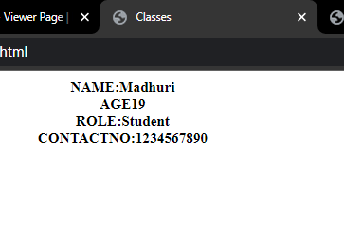

**4.c Course Name: Javascript Module Name: In-built Events and Handlers Write a JavaScript code to book movie tickets online and calculate the total price based on the 3 conditions: (a) If seats to be booked are not more than 2, the cost per ticket remains Rs. 150. (b) If seats are 6 or more, booking is not allowed. (c) If seats to be booked are more than 2 but less than 6, based on the number of seats booked, do the following - Calculate total cost by applying discounts of 3, 5, 7, 9, 11 percent, and so on for customer 1,2,3,4 and 5. Try the code with different values for the number of seats. Write the following custom functions to implement given requirements: (i) calculateCost(seats): Calculate and display the total cost to be paid by the customer for the tickets he has bought. (ii) calculateDiscount(seats): Calculate discount on the tickets bought by the customer. Invoke this function only when the user clicks on a link/button**

**Program:**

<!DOCTYPE html>

<html>

<head>

<title>Booking Summary Using Functions</title>

<script>

var b;

function discount()

{

if(a<=2)

{

document.write("No Discount<br>");

}

else if(a>=6)

{

document.write("invalid no of tickets booked <br> Book tickects in b/w 1 to 6");

}

else

{

if(a==3)

{

b=(150*(3/100))+(150*(5/100))+(150*(7/100));

}

else if(a==4)

{

b=(150*(3/100))+(150*(5/100))+(150*(7/100))+(150*(9/100));

}

else if(a==5)

{

b=(150*(3/100))+(150*(5/100))+(150*(7/100))+(150*(9/100))+(150*(11/100));

}

if(a<6)

document.write("Discount is: Rs."+b+"<br>");

}

document.write("total price is: Rs."+(a*150)+"<br>");

document.write("offer price is:Rs."+((a*150)-b)+"<br>");

}

</script></head>

 <body><center><div>

<h2>Booking Summary</h2>

</div><div>

<script>

var a;

function nooftickets()

{

a=prompt("enter no of tickets");

document.write("no of tickets booked are:"+a+"<br>");

}

nooftickets();

</script>

<input type = "button" onclick = "discount()" value = "Click Me">

</div> </center></body></html>

**Output:**

